Contact: Bob O’Donnell  TECHnalysis Research, LLC  Phone (650) 224-2355  bob@technalysisresearch.com |  | 
Press Release

Worldwide Wearables Market Will Continue to Face Struggles in Near Term, Despite High Profile Entrants

Most Likely Scenario Just Above 40 Million Units in 2015, Growing to 103 Million in 2018
Foster City, CA, November 3, 2014: The market for smart wearable devices has seen the announcement of several high-profile players and products recently, including the Apple Watch and Microsoft Band. Despite these entrants, serious questions remain about the breadth of appeal for wearable computing devices. As a result, TECHnalysis Research is predicting tepid real-world demand for the category in the near term, with worldwide unit shipments expected to just break 40 million units for wearables in calendar year 2015. (As a point of reference, Apple nearly sold that many iPhones in just the third calendar quarter of 2014.) Worldwide smart wearable revenues are predicted to rise from about $2 billion in 2014 to just under $16 billion in 2018.
“While smart wearables are intriguing at many levels, vendors haven’t really been able to articulate a clear, compelling value statement around the devices. That’s left many consumers wondering why, or if, they really need them,” said Bob O’Donnell, Founder and Chief Analyst at TECHnalysis Research. “Given the other challenges associated with the devices, including battery life, sensor quality/accuracy and vendor lock-in, among many others, we expect to see a modest uptake for them in the near term, reaching a respectable level by the end of the forecast.”
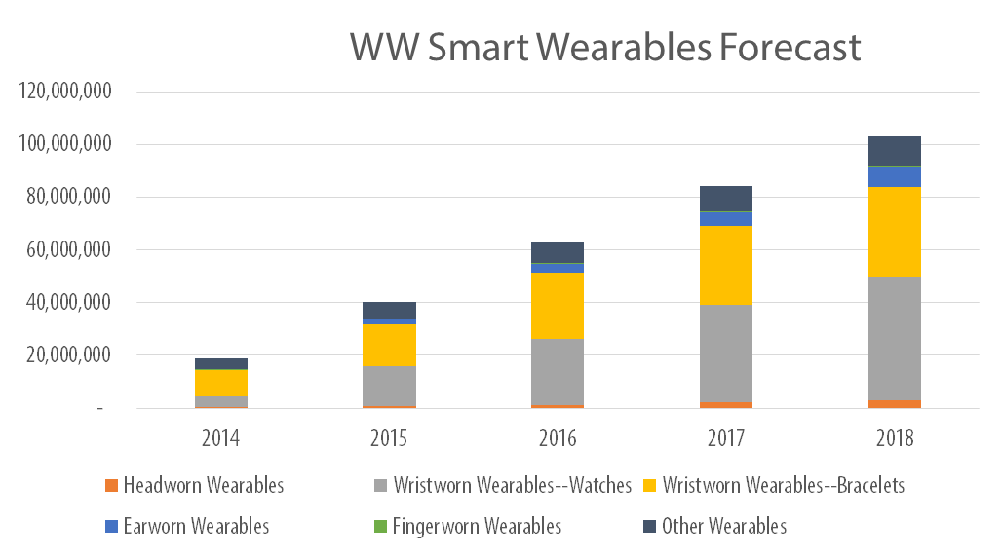©2014, TECHnalysis Research
The newly released wearables forecast report from TECHnalysis Research shows that the vast majority of wearable units and revenues (roughly 75% and 80% respectively) will be derived from the two wrist-worn wearable categories: smart watches and smart bracelets. The report breaks up the market into six separate sub-categories, including head-worn wearables, ear-worn wearables, finger-worn wearables, the two wrist-worn categories (smart watches and smart bracelets) and the “other” wearables category, which incorporates devices such as small activity trackers carried in pockets, as well as others that don’t neatly fit into the defined categories. The report includes unit shipments and revenues for each of the six categories for both the worldwide and US markets. In addition, given the very dynamic nature of the wearables market, the report includes three different forecast scenarios:
- A baseline (or most likely) scenario
- An optimistic scenario, based on an assumption that a few “hit” products could draw an even wider set of customers to the wearables category
- A pessimistic scenario, based on an assumption that hype cycle remains ahead of market realities and the wearables market peters out after a few years of modest growth
A new addition to this version of the forecast is a split between consumer and commercial wearables. Though consumer-focused wearables are expected to own the lion’s share of both unit shipments and revenues over the next five years, commercial wearables are predicted to take 10% of total wearable revenues by 2018.
“Commercial wearables could prove to be the dark horse that actually makes devices such as smart glasses a reasonable success,” said O’Donnell. “Instead of focusing entirely on consumers, wearable vendors would be wise to consider the opportunities in the commercial market.”
DEFINITION: A smart wearable device is a battery-powered, portable electronic device worn on a human body that offers some level of onboard processing and runs some type of integrated software. Most wearables have integrated sensors of various types as well as connectivity options (either wired or wireless) to other smart devices, such as smartphones. Electronic devices that are worn on the body but don’t have their own built-in compute capability, such as basic Bluetooth headsets or heads-up displays, are not considered smart wearables.
A copy of the complete report is available for purchase from TECHnalysis Research. For additional information, please e-mail the author at bob@technalysisresearch.com.
Founded by technology market research veteran Bob O’Donnell, TECHnalysis Research, LLC provides strategic consulting and market research services to the technology industry and professional financial community. Building on a deep understanding of critical technology and business trends, in conjunction with hard-hitting, original research, the firm provides unique "out-of-the-box" perspectives that are still grounded in the practical realities of the technology, media and telecom markets.

